**Electric Circuit ( LAB Report )**

Name : Khaled Mofdi Alshammri

Experiment : 4 ( Kirchhoff’s laws )

Introduction :

In this experiment I will study Kirchhoff’s law in electric circuit and give result my experiment. I need proved that the law is true and applies to my experience

First step : measurement voltage

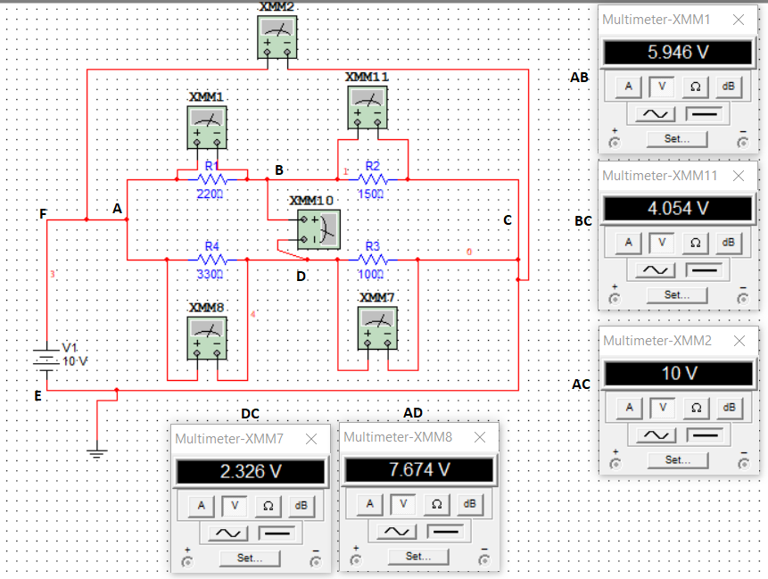

Table ( 1 ) :

|  |  |  |  |  |  |
| --- | --- | --- | --- | --- | --- |
| Vab | Vbc | Vad | Vdc | Vbd | Vac |
| 5.95 v | 4.054 v | 7.674 v | 2.326 v | 1.728 v | 10 v |

Second step : measurement current

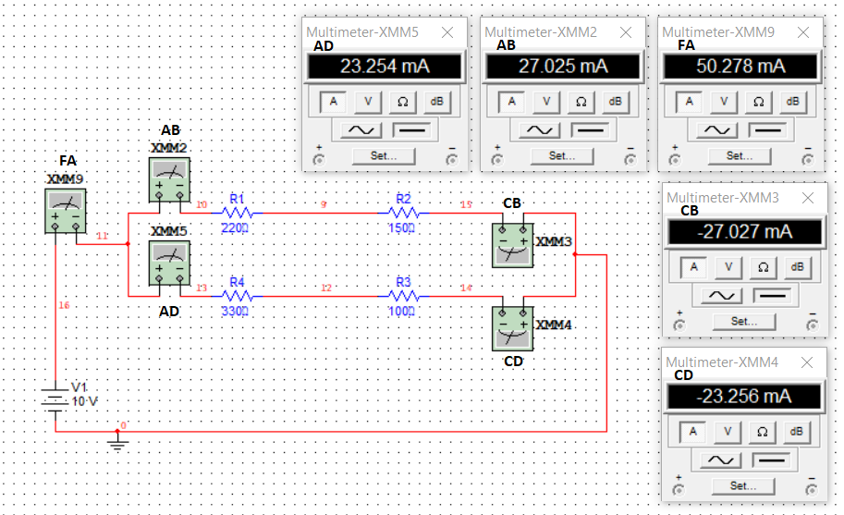

Table ( 2 ) :

|  |  |  |  |  |  |
| --- | --- | --- | --- | --- | --- |
|  | IAB | ICD | IAD | ICD | IFA |
|  | 27.025 mA | -27.025mA | 23.254 mA | -23.256 mA | 50.278 mA |

Third step : Sum off current at nodes Table ( 3 )

|  |  |  |  |
| --- | --- | --- | --- |
| A | B | C | D |
| 50.279 mA | -2× ${10}^{-3}$ A ≈ 0 | -50.283 mA | -2× ${10}^{-3}$ A ≈ 0 |

Calculate a table 3 : KCL

At node A : IAB + IAD = 27.025 + 23.254 = 50.279 mA

At node b : IAB + ICB = 27.025 + -27.027 = -2× ${10}^{-3}$ A ≈ 0

At node c : ICB + ICD = -27.025 + -23.256 = -50.283 mA

At node d : IAD + ICD = 23.254 + ( -23.256 ) = -2× ${10}^{-3}$ A ≈ 0

Fourth step : voltage around loop Table ( 4 ) :

|  |  |  |  |
| --- | --- | --- | --- |
| ABCEFA | ABDA | BDCB | ABCDA |
| 4× ${10}^{-3}$ v ≈ 0 | 4× ${10}^{-3}$ v ≈ 0 | 0 v | 4× ${10}^{-3}$ v ≈ 0 |

Calculate a table 4 : KVL

5.95+4.054-10 = 4× ${10}^{-3}$ v ≈ 0 V

5.95+1.728-7.674 = 4× ${10}^{-3}$ v ≈ 0 V

1.728+2.326-4.024 = 0 V

5.95+4.054-2.326-7.674 = 4× ${10}^{-3}$ v ≈ 0 v

Q 1 ) Are KVL and KCL verified ?

Answer : yes verify

Q 2 ) Give reasons for any discrepancies ?

Answer : Yes, there are differences in Table 3 and Table 4 so that the result appears close to zero, but the result is acceptable

Conclusion :

I have proved that the law is true and applies to my experience after the analysis of the circuit showed some simple errors but the result are acceptable it became clear to me that the current inside is equal to the outside and the voltage in the loop is equal zero .